### **Sample letter to families about reading & the Reads Act**

Families of students in kindergarten through third grade may be hearing a lot from us about reading this year.

A new law - the Alaska Reads Act - requires schools across Alaska to do a few key things:

1. **Check progress**: We will check your child’s reading progress at least three times a year using a short assessment or test called ____ (Amplify/DIBELS or…).
2. **Update families**: You will receive a letter from us after each of these progress checks.
3. **Provide extra support**: If the progress check indicates your child could benefit from extra help with reading, we’ll reach out to you to set up a meeting so we can create an Individual Reading Intervention Plan. If your child has a reading plan, we’ll update you on their progress monthly.
4. **Decide together**: If your child is still reading below grade level at the end of the school year, we will talk with you about having your child progress to the next grade or having them repeat the same grade next year (non-progression). If your child is in third grade, they may also need to participate in summer school if they are not reading at grade-level by the end of the school year.

We’re focused on reading because we know that when children master reading skills by third grade, they do better in school long term. And we also know that when families and schools work together, our students do their very best.

Some of the best things you can do right now to help your child build a strong foundation for reading are to talk, play, share stories and read together.

We also want to hear from you. What seems to be working well for your child? Are they struggling or frustrated? What are you noticing?

If you have any questions or suggestions, please reach out to _____ (name & contact info.)

Sincerely,

Name

Position

PS: Learn more about how to help your child read and the state’s new reading initiative, the Alaska Reads Act, at <https://alaskafec.org/topic/families/reading/>.

### **Sample letter to families to schedule a reading meeting:**

Dear __________ (parent or guardian name)

______ (child’s name) and their class have been working on reading. Our regular progress checks show that _____ (child’s name) could benefit from an Individual Reading Improvement Plan.

We would like to talk with you about how **we can work together to help improve your child’s reading skills**.

Are you able to meet on ______ (date & time) at ______ (location) or on Zoom? Please let us know if this time works for you by returning the bottom of this letter to ______ (teacher or office) or calling or emailing our office to reschedule at _________(number) or email ________.

At this meeting, which can take place by Zoom or in person, we will talk about:

1. **Reading Plan:** We will review your child’s progress and create the plan together.
2. **Extra Support:** We will discuss additional reading support for your child at school.
3. **Home Support:** We will provide tips and hear from you about what is working well at home.
4. **Options:** We will discuss options if your child’s reading doesn't improve by year-end.

We’re looking forward to working together to help your child become a strong reader.

Sincerely,

Name

Position

PS: Learn more about how to help your child read and the state’s new reading initiative, the Alaska Reads Act, at <https://alaskafec.org/topic/families/reading/>. ________________________________________________________________________________________________________________

Thank you for returning this to ______________________________________ (teacher or office staff).

* **Yes**, I can meet on _________ (date and time) to discuss a plan to help ______ (child’s name) with reading.

I would prefer to meet:

* + **At the school** in room _______ (number or name)
  + **Over Zoom**; please email or text an invite to: ____________________________________.
* **No,** I can’t make that time and will call _________(number) or email ________ to reschedule.

Parent or guardian name: ______________________________________________________________________________.

### **Sample letter to families to go with reading assignments**

Your child is bringing home something to read together. They have been practicing this in class and now they get to share it with you.

Your job is simple:

* Give them your full attention.
* If they struggle with a word, give them time to figure it out.
* Try providing hints like, “What sounds do the letters make?”
* Tell them you are so proud of their hard work.

That’s it! When they are done with their reading, feel free to ask them any questions about the story. Common questions begin with the “WH-” words: who, what, where, when, etc.

Thank you for being a great listener for your child as they practice their reading skills.

### **Sample email to families about decodable text**

Your child was hard at work reading a decodable text today. A decodable text is a simple text that uses sound-spelling patterns that they are learning and high-frequency words (words we use often.)

I am so proud of how hard our kids are working! Thanks for helping them continue to learn at home by reading, talking, sharing stories and songs and playing together.

If you have a chance to read simple, decodable stories together, some tips are to:

* Give your child time to figure it out on their own
* Help break down the word. “What letter does that word start with?” “What sound does that letter make?”

### **Videos & Tips for Families:**

Did you know that the Alaska Family Engagement Center has short videos and tips for families about reading and the Reads Act? Find and share them here: <https://alaskafec.org/topic/families/reading/>

### 

### **Questions for Families to about Reading:**

Sharing the following handout with families can help them be a more effective partner in their child’s learning journey.

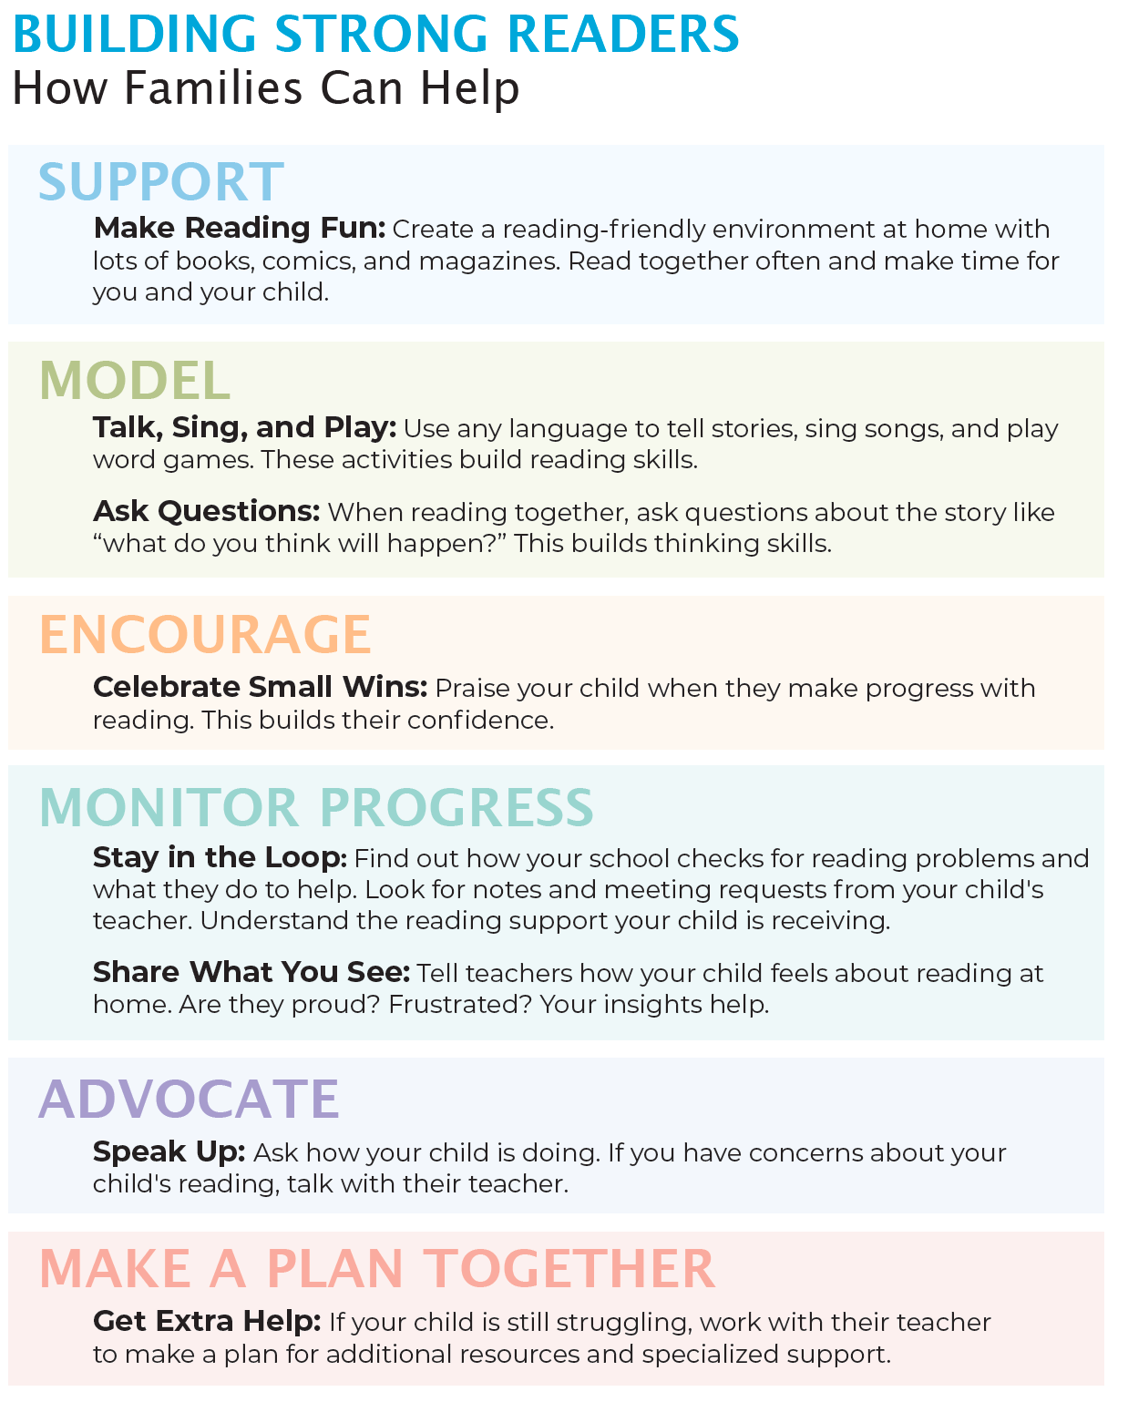

This list was developed in partnership with Juneau-based educators & parents Josh & Misha Jackson.For more tips, tools, and videos check out www.AlaskaFEC.org.



